Phase-2 Project Report

Student Information
Student Name: [Mukesh K]
Register Number: [620623104027]
Institution: [Ganesh college of engineering]
Department: [B.E.CSE]
Date of Submission: [06-05-2025]
Github Repository Link: [Insert your GitHub link]

1. Problem Statement
In the age of digital media, the rapid spread of fake news has become a critical societal issue. Misinformation can influence public opinion, impact elections, and spread panic. This project aims to detect fake news using Natural Language Processing (NLP) techniques. It is framed as a binary classification problem, where the model predicts whether a given news article is 'fake' or 'real'. The model's outcome can aid media agencies and tech platforms in reducing the spread of misinformation.

2. Project Objectives
• Build an NLP-powered system capable of detecting fake news with high accuracy.
• Compare performance of multiple machine learning algorithms.
• Achieve real-world applicability through a balance of performance and interpretability.
• Ensure the model is robust against linguistic variations and biased data.
• The objective evolved post EDA to include explainability using feature importance techniques.

3. Flowchart of the Project Workflow
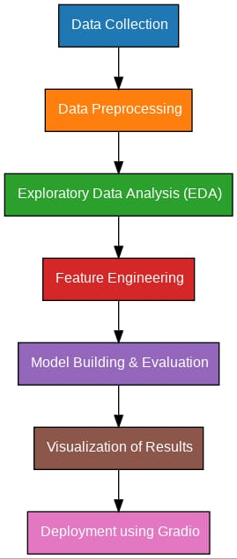

4. Data Description
• Dataset: Fake and real news dataset from Kaggle
• Data Type: Unstructured text
• Records: ~40,000 articles
• Features: Title, text, label
• Target Variable: label (fake or real)
• Static dataset

5. Data Preprocessing
• Removed null values and duplicates.
• Tokenized and cleaned text (removed punctuation, stopwords, etc.).
• Performed lemmatization for word normalization.
• Encoded labels using binary encoding (0 = Real, 1 = Fake).
• Converted text to numeric using TF-IDF vectorization.

6. Exploratory Data Analysis (EDA)
• Univariate Analysis: Distribution of fake vs. real articles, word clouds.
• Bivariate Analysis: TF-IDF word correlation by label.
• Insights: Fake news tends to use more sensational words; real news shows more factual consistency.

7. Feature Engineering
• Created word count and character count features.
• Extracted title sentiment and polarity scores.
• Reduced dimensionality with TruncatedSVD on TF-IDF features.

8. Model Building
• Models Used: Logistic Regression, Random Forest Classifier, and XGBoost
• Justification: These models handle text classification well and allow interpretation.
• Data Split: 80% train, 20% test using stratified sampling.
• Metrics: Evaluated using Accuracy, Precision, Recall, F1-Score.

9. Visualization of Results & Model Insights
Below are visualizations showing model performance.
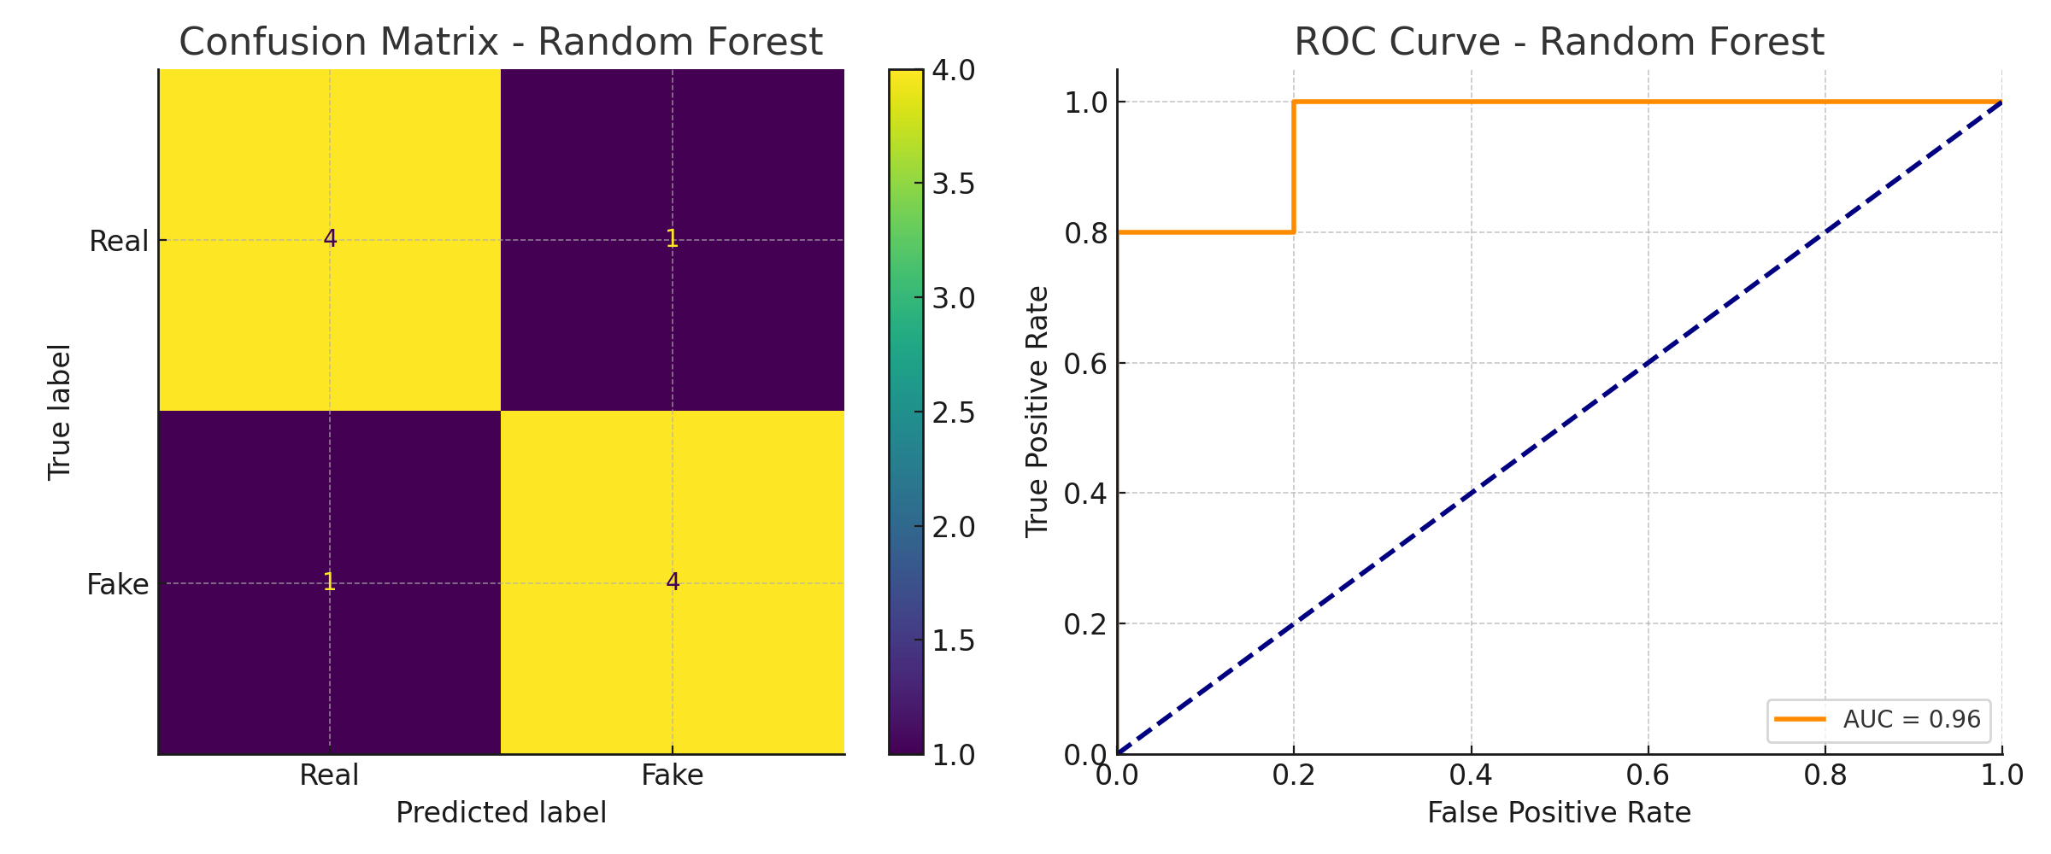

10. Tools and Technologies Used
• Language: Python
• IDE/Notebook: Jupyter Notebook, Google Colab
• Libraries: pandas, numpy, sklearn, nltk, seaborn, matplotlib, xgboost
• Visualization Tools: seaborn, matplotlib, SHAP

11. Team Members and Contributions
• [Ponram S R]: Data cleaning.
• [ Mukesh K]: EDA
• [Navaneethakrishan K]: Feature engineering.
•[Naveen K] : model development.
• [Nithishnathan P]: Visualization.

